# DRIVERS AND BASIC MODELING OF NATURAL GAS PRICES IN THE US

In the last decade, United States has experienced the massive application of a technological revolution called well fracking. This technology has allowed E&P (exploration and production) companies to produce hydrocarbons from shale geological formations, most well know as non-conventional reservoirs. The consequences of this fascinating phenomena translated into a huge positive economic impact to US economy. Since the price of a product reflects fundamentals of a specific market, such as supply and demand, the purpose of this document is to answer some questions related to natural gas prices and their economic drivers using data analytics. Therefore, we organize this report in a set of questions contained in three sections:

1. Supply drivers
2. Demand drivers
3. Price

# Supply Drivers questions

## **How does production vary over time around the country?**

**Figure 1 and figure 2** demonstrates two clearly facts: a continuous steep increase of production over time in the United States, and a modest consumption increment rate with cyclical behavior. The difference of these increase rates produced a declined trend for natural gas prices over time.

Figure 1



Figure 2

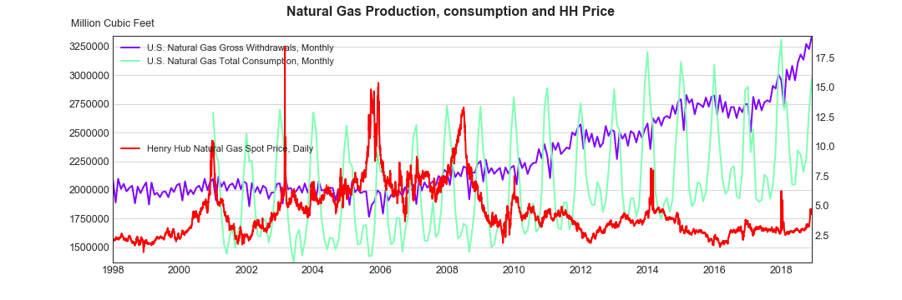

Another fact supporting this tendency is the continuous increase of proved reserved volumes, despite lower prices, as depicted in **Figure 3**. Moreover, **figure 4** demonstrates that over time Texas has been the most productive state. On the other hand, Pennsylvania's natural gas production has been steadily increasing since 2002. Altogether, these data suggest that a rise in natural gas production volume in the coming years may keep prices down unless internal consumption and exports show some relevant boost.

Figure 3

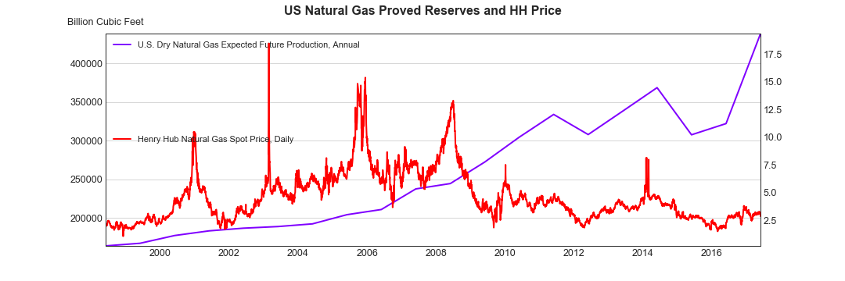

Figure 4



## **How do natural gas imports contribute to the supply over time?**

**Figure 5** demonstrates that as the volume of natural gas imports decrease the export volume increase. The decrease of natural gas imports in the recent years is associated with an increase of natural gas production and reserves in the country over the pasts 10 years as observed in **figure 6**. The US is the largest natural gas producer in the world. This is due in part to increased efficiency in the production of natural gas and fracking technology. This has contributed to the US no longer being reliant on imports and has led to the increase of exports as the demand for natural gas has increased in other countries.

Figure 5

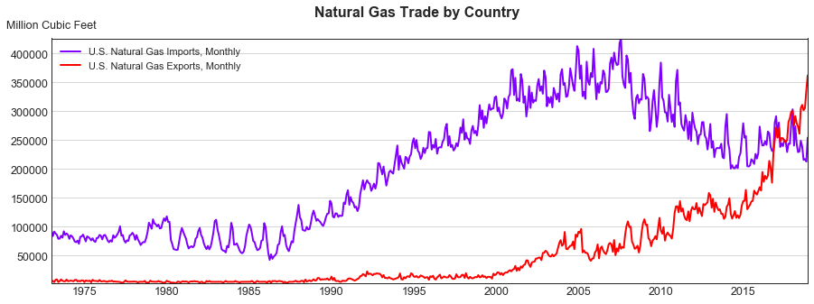

Figure 6



# Demand questions

## **How does natural gas consumption evolve in US?**

As shown in **Figure 7,** California and Texas are the states where most of the gas is consumed over time. Most of the consumption in these two states is by industrial and commercial businesses. Petrochemical plants and refineries are the major consumers of natural gas in those states. Also, weather plays a big part in natural gas consumption with states in colder regions consuming large amounts of natural gas in the winter for heating. In the summer, more natural gas is consumed in warmer states by power plants to provide electricity for cooling. The transportation sector also has the potential to increase the demand for natural gas. There is a shift away from carbon-based fuels and natural gas could displace those fuels as the primary means to power vehicles in the future.

Figure 7

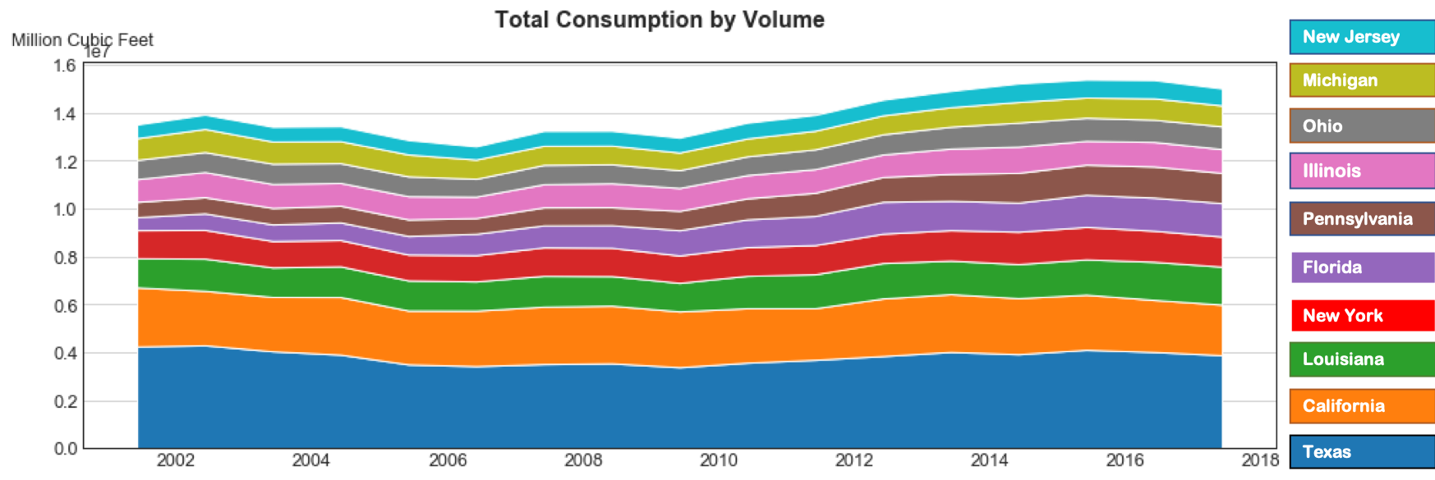

## **How do natural gas exports change over time?**

As observed in **figure 4**, natural gas exports have experienced an exponentially upward trend as a result of increase in internal production and gas reserves as portrayed in **figure 3**.

## **How does seasonal effects affect gas demand?**

The demand curve presented in **Fig 2** shows the seasonal effects for natural gas demand. In colder regions, the demand for natural gas increases during the winter to meet the warming needs of consumers in those regions. The demand for natural gas increases during the warmer months as power plants need to provide more power to meet the cooling needs of its commercial and residential consumers.

# Price questions

## **How does natural gas price relate to demand and supply drivers?**

In order to gain awareness of how natural gas prices relate to demand a supply component, we use the following time series:

1. Monthly Average Henry Hub prices updated to US$ 2018
2. US Gas production
3. US Gas consumption
4. US Gas Storage Capacity
5. Imports
6. Exports

Then, we calculate a correlation matrix, which is shown in **figure 8.** As we can observe, the variables present reasonable positive or negative correlation with each other.

Figure 8

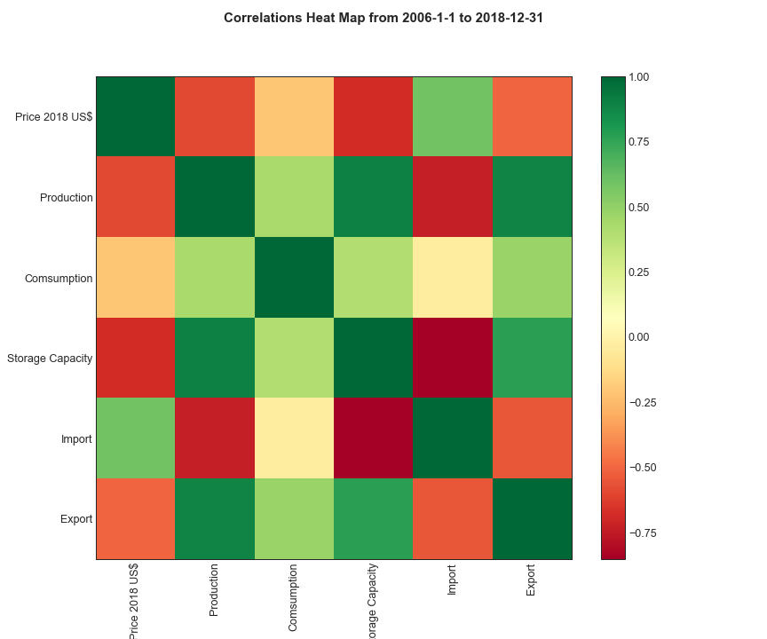

Taking advantage of the correlation results, we decided to make a linear regression to forecast prices using supply and demand drivers. The results are shown in **Fig 9**. We can observe that the drivers are able to reproduce the trend but not spikes and other information contained in the prices.

Figure 9



Now, to see how changes of a specific driver affects changes in price, we performed a linear regression for price against each driver. In this case, the null hypothesis is “changes is driver x does not cause any change in natural gas prices”.

The Table in **Figure 9** depicts the results of these linear regressions. Since the “p” values are extremely low, we have to reject the null hypothesis. Therefore, the answer of the questions will is that the natural gas prices strongly relate to economic drivers.